Montgomery Township Education Foundation
P.O. Box 171
Skillman, NJ 08558
MTEFNJ.com
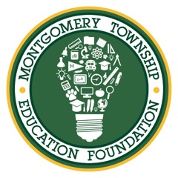

January - 2018
Dear Montgomery Business Owner/Manager:
The Montgomery Township Education Foundation is an independent, non-profit organization set up to support strategic programs for the benefit of Montgomery Township public school children. The Foundation’s goal is to raise money for the purpose of improving our children’s educational experience. The MTEF works closely with the superintendent, as well as all of the school’s principals, to identify and fund projects that enhance programs in academics, arts and athletics, as well as provide assistance for students who are academically at-risk.

Your business can help us by donating goods and services that will be a part of our silent auction at the MTEF’s annual fundraiser on Saturday, April 14, 2018. Your donation will be prominently displayed at this event and will demonstrate your business’ support for this very important organization within our community. Please contact Ashley McFadden (609) 240-5325 with any questions you may have or to schedule a time to pick up your donation.
Thank you in advance for your generosity and continued support for the education of Montgomery’s children. A copy of our tax-exempt certificate is attached for your records.
Sincerely,
The 2018 MTEF Board and Planning Committee:

Christine Petrane, Co- President
Christine Zoffinger, Co-President
Steve Shueh, Vice President
Jigna Patel, Treasurer
Rebecca Casiano, Secretary
Mary Ann Post, Grants Chair
Ashley McFadden, Events Chair
Patricia Edelstein, Events Chair
Melissa Chang Qi, Scholarship Chair
Samuel Kim, Scholarship Chair
Mark Edelstein, Trustee
Michael Garrison, Trustee
David Zhang, Trustee

